# **Game Theoretic Cognitive Strategies for Deceptive Military Decision Making**

# 

# Semester Research Project Report

# By

# 

# **Nitin Agrawal**

# **Raghavendra Tripathi**

# **Shikhar Sharma**

# **Shivam Sharma**

# 

# Under the guidance of

# **Dr. A.K. Sinha, Scientist ‘G’**

# 

# logo.png

# Defence Terrain and Research Laboratory

# Defence Research and Development Organization

# Ministry of Defence

# January 2015

# Index

# 

# 

# 

# Abstract

# 

# 

Military decision making is a complex process especially in pursuit evasion scenario wherein autonomous agents are artificially equipped with intelligence. The situation further gets typical when deception is employed. The current study aims at evolving models for decision making scenarios such as habitat selection, ambush avoidance and dilemma resolution. Game theoretic techniques have been employed for $2 x 2$ and $4 x 4$ ambusher-evader games. Furthermore, cognitive models based on theory of mind are evolved to detect and take counter-measures to deception.The present work deals with a Cognition based modelling to analyze scenarios of Habitat Selection, Dilemma Resolution and Deception

# 

# 

# 

# 

# 

# Chapter 1 : Introduction

# 

## 1.1 Ambush

Defence and Monitoring in border areas requires an inclusion of wide range of tactics to establish various advantageous scenarios in terms of information and strategic superiority. Some of these tactics are camouflage, guerrilla warfare, human wave attack, hull down and ambush. Ambush is a tactic which has been widely employed both in recent and historical times. Ambush relies on leveraging the advantages of local domain knowledge and favourable environmental situations to present an element of surprise for an unsuspecting enemy. Concealed positions such as under a dense bush and other types of hidings in a forest or a hilly terrain scenario are employed as intentional strategic attack points. Ambush is done in a variety of formations such as Linear (parallel to enemy route), L-shaped and V-shaped ambush. Assault, support, security and withdrawal are some essential elements of ambush. Ambush operations are complex and require quite a bit of planning beforehand. The ambush site, timings, methodologies and fallback mechanism are essential parameters to be decided. The terrain to conduct an ambush or the ambush site is another important element. In case of an evader-pursuer scenario ambush plays an important role in tracking and capturing of the evader (Fig 1.1). While the evader may try to suspect an ambush the defence attempts to carry out a successful ambush. As mentioned, obstacles and environmental factors have a key influence in such interactions.

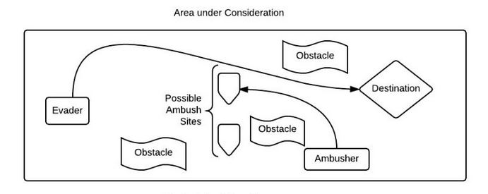 Fig 1.1 : Ambush in military scenarios

# 

# 1.2 Deception

Deception is an everyday part of life. Voluntarily or Involuntarily we come across and perform various deceptive measures around us. Degree/Impact of deception can vary immensely according to different situations. It can be used in simple situations like giving an intentional false opinion to an entity for the purpose of appreciation (Employee-Employer scenario) or it can be used in highly serious situations such as courtroom testimony . Continuous judgement and observations lead an individual to adapt deceptive measures in various temporal and spatial scenarios. In military and defence operations, deception is a central parameter around which various strategies revolve. On the other hand an infiltrator can also use the same tool for fulfilling his propaganda. Camouflage is also a form of deception. Deception can be achieved through intentional communication of false propaganda and objectives of an entity. Deception involves propagating false or half truth information. It is basically developing a wrong belief in the mind of a party with conflicting interests as of ours. It is noted that generally people are poor detectors of Deception [1]. The reason for this is that in a communicative scenario the receiver tries to interpret the message being sent by sender and this is done post formation of a basic assumption that the message is comprehensible and truthful. Lies, Equivocations, Concealments, Exaggeration and Understatements are five primary types of deception (Fig 1.2).

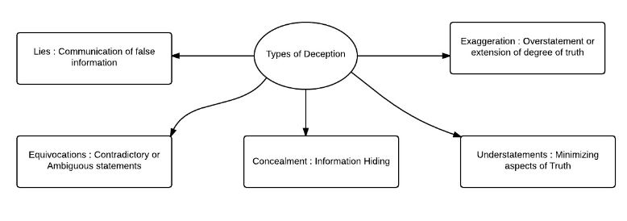

Fig 1.2 : Types of Deception

There have been several theories pertaining to Deception. One notable among these is the Interpersonal deception theory by Buller et al [2]. It explains the manner in which individuals respond or perform the act of deception at both conscious and subconscious levels .It is based on a set of 18 empirically verifiable propositions. It also takes in account parameters such as emotions, facial expressions etc. However, it has also been subjected to criticism at various points for different reasons. Another reason why people have difficulty detecting deception has to do with their preconceptions of what are accurate cues to deception. For example, absence of eyesight contact and certain facial expression are some cues to deception . IDT is dynamic and takes into account the feedback post communication. Deception in agents is often linked to a Theory of Mind Model (or a Belief-Desire-Intention based model) as will be covered in the following sections. Military robots capable of deception could mislead opponents in a variety of ways. As both individual and teams of robots become more prevalent in the military’s future, robotic deception can provide new advantages apart from the more traditional one of force multiplication. In other areas, such as search or healthcare, deceptive robots might also add value, for example, for calming victims or patients when required for their own protection. Conceivably even in the field of educational robots, the deceptive behavior of a robot teacher may potentially play a role in improving human learning efficiency. Agent based deceptive models are often analyzed using game theoretic approach.

## 1.3 Examples of Deception

An important example of deception is provided by Dragan et al [3]. Many organisms such as squirrels show deceptive behaviour in food hoarding. Food Hoarding consists of two parts food caching and food protection. The deceptive component is the food protection part. Scatter hoarders cache a few items in many small/scattered caches. On the other hand, larger hoarders place most of the food in one or a few central locations referred to as middens. The evolution of the particular hoarding strategy for a species depends on the abilities of individuals to defend their caches against pilfering. Deceptive behavior in the tree squirrel has been observed with respect to food protection . While patrolling, tree squirrels visit the cache locations and check on their food. However, if potential competitors are present nearby, tree squirrels visit several empty cache locations. This deceptive behavior attempts to confuse competitors about the food's location, so that they can protect against the loss of their hoarded food. After the potential competitors leave the territory, the tree squirrels move the location of their stored food items, if pilfering has occurred.

Deception is also important in military scenarios. Here, a force which has a better knowledge of the mindset, beliefs, objectives and other characteristics of an enemy can employ deception to gain various advantages. Lets consider a trajectory based scenario. An evader in a territory takes an intentionally predictable trajectory such as moving from one hide out to another based on nearest distance (Fig 1.3). This leads the defense personnels into believing that they are aware of the evaders trajectory and can catch him using it. However,since the evader employs deception he suddenly changes his trajectory and chooses a different one. This misleads the defense and evader can proceed in the territory easily.

Conversely, the defence can mislead an infiltrator and put a path in front of him which has less obstacles and an abandoned shelter . The infiltrator visits the shelter but is subject to an ambush near the shelter. All these cases involve providing a false communication to the opponent.It is further noted that information superioirty, domain knowledge and knowledge of the opponent beliefs are key aspects of deception.

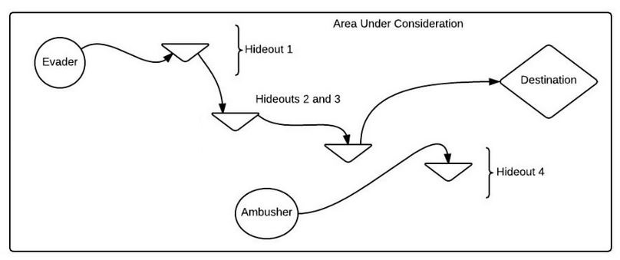

Evader initially moves intentionally in a pattern to nearest hideouts.Ambusher observes this and plans ambush at hideout 4 but is deceived as evader changes the trajectory according to his deceptive measures

Fig 1.3 : Example Deception Scenario

# 

# 

# 

## 1.4 Habitat Visit

In the scenario of an infiltrator/evader entering a territory with certain objectives followed by the defence at the region , local habitats and people living in those habitats play an important role in the interaction process. An evader is on a mission and with the progress of temporal and spatial parameters, it suffers certain losses in different terms. These losses may either be in terms of ammunitions, health or any other type of loss. Hence an evader requires certain areas/spatial domains where he could take a temporary stay and recover his losses. Local Habitats in border areas prove to be one of such a resource for the evader. There may be a single habitat or multiple habitats that he could choose depending upon the situation. People residing in the habitats may or may not be pro-evader. It is evident that certain areas are pro-evaders because of certain barriers with their own countries and similarities with the evader. They may assist the hideout and recovery for the evader in that case. On the other hand, the defence is fully aware of such scenarios and tries to use these habitats as capture or ambush points. They try to ‘win over’ the population of the habitat. Here, ‘win-over’ refers to convincing them to support the defence and taking assistance to ensure capture of evader. The evader has to decide which habitats he has to visit and defence has to plan which habitats they have to win over (Fig 1.4). Moreover, it is not necessary for the defence to ‘win-over’ a habitat. They could also choose to just ‘penetrate’ the habitat hoping the population would not be pro-evader. This saves certain resources of defence and also gives them a chance to capture the evader.

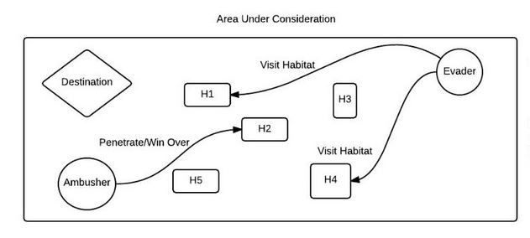

Evader while moving towards the destination may lose some resources such as health, ammunitions etc. He can recover these resources by visiting the habitats. On the other hand an ambusher can either penetrate or win-over a habitat to capture the evader or make him suffer certain losses.

Fig 1.4 : A Habitat Visit Scenario

It is evident that both the evader and the ambusher have to choose from multiple options. The choice may be governed by the present situation, future requirements, certain beliefs or merely by intuitive measures. The evader has to choose which habitats he needs to visit and his particular objectives to that. Moreover, he needs to take in account the possibility of the ambush and nature of the population at the specific habitat. On the other hand, defence has to figure out which habitats could the evader visit and with what probability. They also need to decide whether to win over or just penetrate the habitat. Thereby there lie certain strategies for each side and the interaction develops a game theoretic scenario.

This game theoretic scenario is also driven by certain cognitive capabilities, certain beliefs, desires and intentions. The scenario can be well modelled combining the game-theoretic approach with a Cognition based Theory of Mind approach which will be introduced in the coming sections.

## 1.5 Cognitive Model and Theory of Mind

Cognitive models are used to simulate human problem solving and mental task processing in a computerized model. A cognitive model combined with a theory of mind approach is used to simulate various interactions in different military scenarios. Theory of mind helps in providing a framework to represent the beliefs, desires, intentions and knowledge of a human being basically assisting in modelling the way in which humans think. A cognitive model attempts to mimic the functionalities of various human cognition abilities such as memory, knowledge, attention, problem-solving, sensory processes and decision processes. Fig 1-5 shows a the main components of a generalized cognitive model [4] such as an Executive and a Manager and its related cognitive processes.

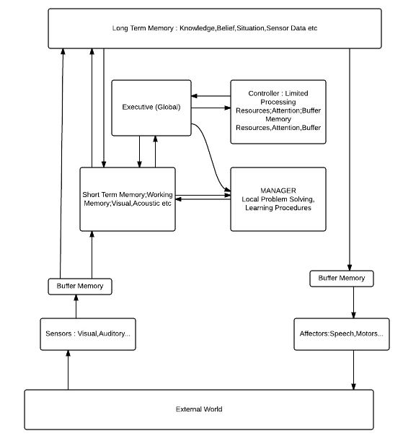

Fig 1.5 : System Components of a cognitive model

**Executive** : High level awareness and control processes

**Controller** : Processing Resources and attention control

**Manager** : Problem Solving,Thinking and Learning

**Sensors & Effectors** : External Input and Output processes

Our decisions to act are influenced by how we believe others will react. Whether we believe a message depends not only on its content but also on our model of the communicator. Giving its importance in human social interaction, modeling theory of mind can play a key role in enriching social simulations.

**Theory of Mind (ToM)** is a cognitive capability that allows us to understand another’s internal states (intention, goal, and belief) and predict future behaviors of others [5]. From the observation of other’s behavior, facial expression, and speech, we can infer the person’s internal state (emotions, thought, decision making, and plans). ToM plays a vital role in representation of situations involving cognitive abilities. Theory of Mind can be exploited by an agent in two different manners. The first manner is just to predict the behaviour in advance, in order to be prepared that it will occur. A second manner to exploit reasoning based on a Theory of Mind is to try to affect the occurrence of certain beliefs, desires and intentions at forehand, by manipulating the occurrence of circumstances that are likely to lead to them. Theory of mind can be applied at various levels. A zero level ToM pertains to what an agent thinks about his own self, that is how does he represent his own thinking. In a first level TOM an agent tries to attain the most close representation of what his opponent (in game-theoretic sense) believes and what are his desires, intentions etc. At the second level an agent A thinks of what another agent B thinks about the belief, desire and intentions of agent A. Likewise, the levels proceed further. Theory of mind can be modelled in multiple manners that is using state vectors, functions, probabilistic models, game theory based models etc.

Kim et al [6] use a co-evolutionary setup to evolve controllers that retrospectively explain an observed actor’s behavior, and new actions that elicit new and more revealing behaviors. Evolved controllers can then be used to predict, manipulate and exploit the observed actor’s behavior for cooperation or competition. A Theory of mind simulation is done based on game theoretic formulations in Game Theory of Mind [7]. A software Psychsim [8] for an Agent-based modeling of social interactions and influence has been built in a bullying scenario at a school. Here beliefs of various entities such as bully, teacher, crowd etc are represented as state vectors and these are updated at various times post obtaining feedbacks/reactions.

Theory of mind is most commonly modelled using a BDI or a Belief-Desire-Intention model. The BDI-model incorporates such a pattern of reasoning to explain behaviour in a refined form. Instead of a process from desire to action in one step, as an intermediate stage first an intention is generated, and from the intention the action is generated. It is based upon the fact that agents have and develop certain beliefs. They also have certain desires and intentions to perform certain tasks. Combining this with a non cooperative game theoretic formulation which generally takes place in military scenario, it becomes of paramount importance to develop an accurate Theory of mind to base the cognitive model on. Furthermore, we can combine Ambush, Deception and Habitat visit using a cognitive model based on a Theory of mind and in a game-theoretic perspective. This brings us to the problem definition which is covered in the following subsection.

## 1.6 Problem Definition

### 1.6.1 Entities

Evader/Infiltrator is trying to reach a final destination while avoiding pursuer, ambushers and different types of obstacles that are present in the field.

Pursuer has a single aim to catch and kill the infiltrator whenever it comes in its field of attack before the evader reaches its final destination.

Ambushers are immobile agents who are totally hidden and can’t be recognized by other agents. They are hidden in ambush structures and destroy the evader if it enters their field of vision.

### 

### 1.6.2 The Terrain

The terrain has different types of regions,obstacles and habitats described as follows :

No-Go Regions are regions in which passing is not possible or highly dangerous.These regions can be either a deep and stretched water body,mine areas,extremely steep terrains etc.

Slow-Go Regions are the regions where movement is slow.These regions can be swampy areas,water-logged areas,hilly areas etc.

Obstacles are various kind of obstructions or rigid/non-rigid structures which affect the motion adversely and require efforts and usage of certain resources to cross them.They may or may not inflict certain damage.

Habitats are areas occupied by human population which an evader can use to replenish resources,regain health and other purposes.Population may be pro evader or anti-evader.It can also be served as an ambush point.

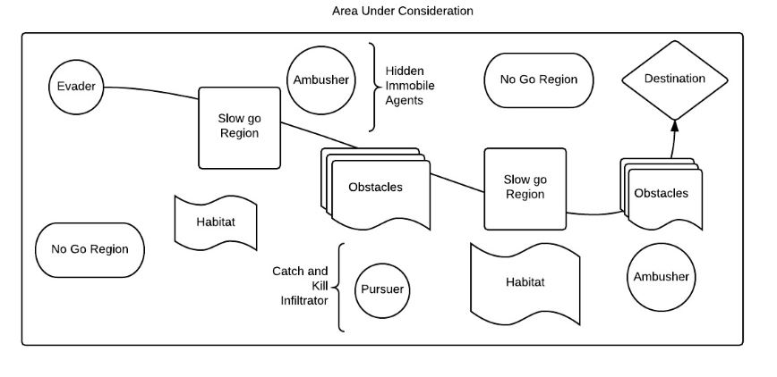

Fig 1.6 : Problem Scenario

Various scenarios in the described terrain form the basis of analysis. Firstly, how does a simulation progress/evolve when an evader has to decide whether he is being ambushed or if there is a chance of ambush in vicinity. Secondly, evader tries to reason if there is a deception being presented to him in terms of ambush scenarios. Moreover, evader also tries himself to deceive and uses the related strategies to inflict false believes and information. Analysis of loss and gains post habitat visit at certain spatial and temporal coordinates is also undertaken. These approaches are also analysed in conjunction, viz, ambush in habitat selection etc. The following sections describe how Cognitive Models using Theory of Mind and Game Theoretic formulations are used to analyze various scenarios that may take place in the terrain situation.

# 

# Chapter 2 : Game Theoretic Modelling of Ambush Avoidance Strategies

## 

## 2.1 Habitat Selection

As introduced in the previous chapters, a habitat presents an opportunity for an evader to top-up its resources while on its evasion task, however what is crucial is the decision making process for an evading agent to precisely zero down to a habitat, given the risks involved. The habitat acts as a proactive ambush sites and therefore presents onself with a plethora of risks for an evading agent. This decision making process gets further complicated when multiple habitats are introduced and it’s for the agent to decide which all habitats need to be visited and their corresponding order.

## 2.2 Habitats as ambush sites

Habitats acts as convenient ambush sites. The ambushers can adopt various strategies with an habitat in order to ambush the evader since it is highly likely for the evader to visit a habitat. However a complex decision making process goes into deciding the strategy to be adopted. The habitat too needs to be chosen in case of a multiple habitat scenario

## 2.3 Single Habitat Model

In the current work, a single habitat scenario has been modelled using game theoretic techniques under following premises.

1. The evader has two possible strategies
   1. To visit the habitat
   2. To not visit the habitat
2. The ambusher has two possible strategies.
   1. To penetrate into the habitat

This involves presence of an ambushing agent in the habitat premises in order to encounter the evading agent, however the agent doesn’t interact or take support of the inhabitants.

* 1. To win over the habitat

This involves not only involves presence of an ambushing agent in the habitat premises, but also involves the interaction and winning over of the location inhabitants.

The problem could be formulated as $2 x 2$ game as explained in fig 2.1. The corresponding payoffs for each of the columns are represented by an alphabet. The matrix here is a zero sum game devised for the ambusher, wherein a positive payoff value is a gain for the ambusher and an equivalent loss for the evader, while a negative payoff value is a gain for the evader and an equivalent loss for the ambusher.



Fig 2.1 : Game theoretic approach to a single habitat game

The primary deciding factor for an evader about how often he should visit a habitat is the value of the ambusher’s penetration in that habitat. If the value of ambusher’s penetration in a habitat is high then the evader shall less often visit that habitat and would try to avoid it conversely if the value of the ambusher’s penetration for a habitat is low the evader is more proactive in visit that habitat owing to high prospective gains. In particular if the value of ambusher’s penetration is lower than the value of attacks on the evader or on the ambusher then the evader shall engage less often.

It’s of course natural that assigning a high value to the evader shall make him more conservative about himself, however it may not come naturally that assigning a high value on capturing the ambusher would drive the evader to follow a orthodox conservative strategy, if the evader clauses under these circumstances, he shall act in a conservative manner. Yet, assigning a high value to the ambusher shall make himself take more precaution and devote more resources for penetration which shall inturn make the encounter of the ambusher with the evader even more dangerous for the evader.

## 2.4 Illustrative scenarios for a single habitat game

In this section, we explain the formulation of a $2 x 2$ game matrix under variety of scenarios and their corresponding graphical inference.

1. When in a evasion habitat scenario ambusher carry’s a vital equipment for installation at a habitat while an evader may or may not visit that habitat. The situation could be idealised as a following game matrix.



Fig 2.2 :The game matrix for scenario A

The payoff for penetration of the ambusher while evader visits is beneficial for the evader since, in that scenario ambusher will suffer loss of the equipment as well as the human resource. Ambusher’s penetration while evader doesn’t visit the habitat has a highly positive effect for the ambusher since she’s able to plant the vital equipment without an aggression from the evader, moreover she’s able to save her resource diversion which was otherwise have been required for winning over the habitat. In a situation wherein the ambusher wins over the local inhabitants and the evader visits the habitat, the ambusher undergoes a moderately positive gain since able to cause considerable damage the the evader on account of her being ambushed and may even have been able to plant the vital equipment, however some cost in terms of resource diversion for winning over the habitat would have been born by the ambusher conversely if the evader doesn’t visit the habitat which has been won over by ambusher, it’s a neutral situation for both, since no damage could be caused to the evader while ambusher gains in terms of her success of planting the vital equipment while she suffers an equivalent loss in diverting her resource for winning over the habitat.

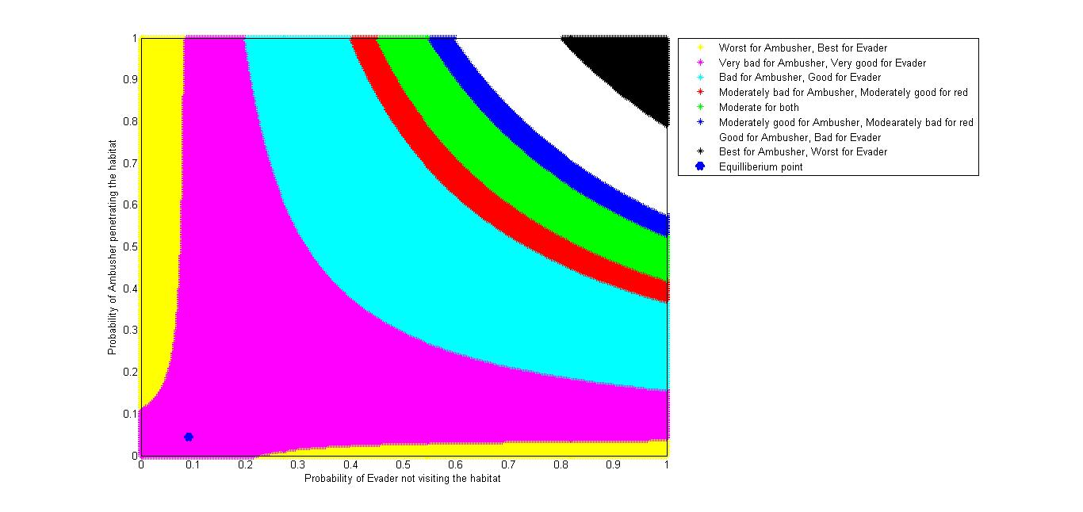

Fig 2.3 : Graph depicting the solution set for the game as described in scenario A

Owing to the nature of the game matrix we shall not have pure strategies for both the players. One shall need to resort to mixed strategies for achieving the nash equilibrium. Fig 2.3 above explains the distribution of the game value for different mixed strategies with respect to the scenario A. The $x-axis$ represents the probability of evader not visiting the habitat while the $y-axis$ represents the probability of ambusher penetrating the habitat. Based on the game values and their corresponding impact on the ambusher and the evader the solution set have been divided into various region of varying payoffs for the ambusher and the evader as indicated in the legends for the Fig 2.3 above. Moreover, nash equilibrium has been computed which has been indicated by the blue dot. The equilibrium thus obtained is as follows :

0.0455 : Probability of the ambusher choosing penetration over winning over the habitat

0.10 : Probability of the evader choosing to not visit the habitat

4.55 : Value of the game at the equilibrium

1. When the ambusher isn’t carrying any vital equipment and the value of the ambusher’s penetration when the evader doesn’t visit is low as compared to the value of ambushing soldier or evading infiltrator, the sole aim of the ambusher is vested with is to ambush the evader, then the situation could be idealized by a game matrix similar to the following one.



Fig 2.4 : The game matrix for scenario B

Fig 2.4 above portrays the game matrix formulated for scenario B. The ambushers suffers a hefty damage on penetration while the evader visits and encounter the ambusher, however the damage is not caused in case the evader doesn’t visit. On the contrary if the ambusher wins over the habitat and similar damage is caused to the evader in case she visits owing to an encounter with the ambusher who's in a position to kill the evader owing to the local support, this damage to the evader is of the order of the damage the ambusher would have suffered in a penetrated state on evader’s visit. When the habitat has been won over by the ambusher in absence of evader’s visit the situation in neutral for both the evader and the ambusher.

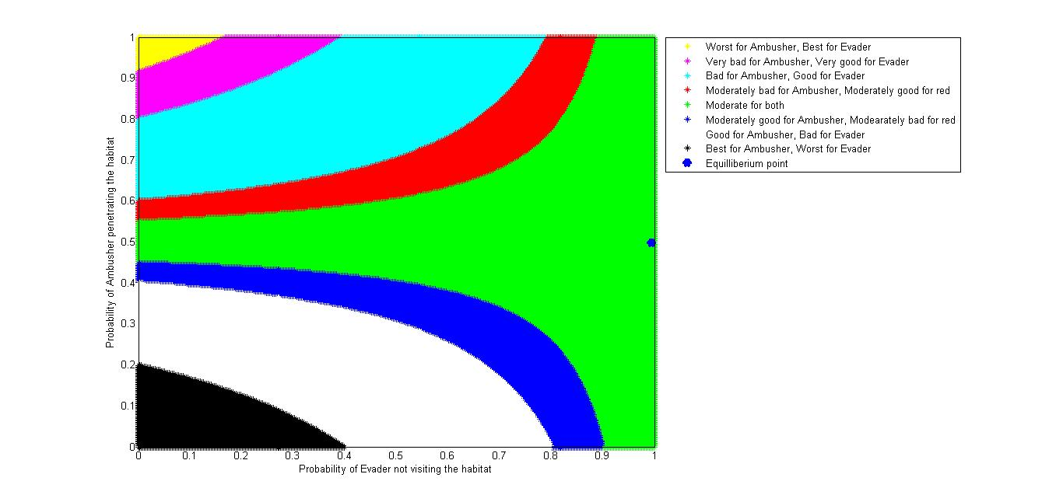

Fig : 2.5 : Graph depicting the solution set for the game as described in scenario B

Fig 2.5 above explains the game values when different mixed strategies are followed as indicated in the legends. The nash equilibrium computed in this case is as follows :

0.4975 : Probability of the ambusher choosing penetration over winning over the habitat

0.995 : Probability of the evader choosing to not visit the habitat

0.49 : Value of the game at the equilibrium

## 2.5 Two Habitat scenario

In a two habitat scenario the decision making process gets even more complicated for the ambushing and the evading agents. They are no more presented with two possible strategies each rather they now have four possible strategies which each of them at their disposal. The ambusher has an option to either penetrate or win over either of the two habitats while evader has an option to visit either or both of the habitats. Moreover the order have visiting the habitats could be crucial in a scenario wherein the evader decides to visit both the habitats owing to the fact that the resource gain / loss at one of the habitats could affect the payoffs for the other habitats, moreover ambusher’s presence / absence in the first habitat to be visited shall make it possible for the evader to deduce about her presences / absence in the next habitat. The premises for the two habitat situation are as follows

1. The evader is vested to following four strategies out of it she can choose one depending on the game matrix.
   1. To visit habitat 1
   2. To visit habitat 2
   3. To visit both the habitats while visiting habitat 1 first
   4. To visit both the habitats while visiting habitat 2 first
2. The ambusher has the following for strategies for itself to adopt
   1. To penetrate habitat 1
   2. To win over habitat 1
   3. To penetrate habitat 2
   4. To win over habitat 2

The game matrix for a two habitat scenario could be formulated as devised in fig 2.6



Fig 2.6 : Two Habitat Scenario Matrix

It is strategically difficult to logically assign value to the 16 payoff values enumerated as $a,b,c,d,e,f,g,h,i,j,k,l,m,n,o,p$. A model is therefore is being proposed here to formulate this $4 x 4$ game.

### 2.6 Formulation of $4 x 4$ game matrix for a two habit scenario

The model being proposed herein assumes the premises as described in the previous section. In addition to them it assumes that the order of visiting the habitat incase both the habitats are being visited by the evader only affects the benefit being drawn by the evader from visiting the each of the habitats, all other parameters remain constant. It’s also assumed that only the evaders suffers a damage on visiting a habitat that has been won over by the ambusher while in a situation wherein the habitat has been penetrated by the ambusher the converse is true.

$V_{h{}_{i}}$: Benefit derived by the evader by visiting the ith habitat

$V_{h{}_{i|j}}$: Benefit derived by the evader by visiting the ith habitat while already having visited the jth habitat

$B_{p{}_{i}}$: Cost incurred to the ambusher for penetrating the ith habitat

$B_{w{}_{i}}$: Cost incurred to the ambusher for winning over the ith habitat

$R_{dp{}_{i}}$: Damage suffered by the evader on encountering the ambusher (penetrated state) at the ith habitat

$R_{dw{}_{i} }$: Damage suffered by the evader on encountering the ambusher (won over state) at the ith habitat

Using these six parameters, the game matrix can then be realised in the following manner



Fig 2.7 : Two habitat game matrix

## 

## 

## 2.7 Non - habitat ambush scenarios

In non-habitat scenarios the possible ambush sites are detected by the evader using the sensory data and inculcated intelligence. A natural strategy would be to always avoid the suspected ambush sites, however their non-avoidance may be of gain to the evader. Therefore, these ambush sites are avoided or not avoided based on their corresponding game matrix and viabilities.

# 

# Chapter 3 : A Mathematical Approach To Deception

Deception is one of the most prominent cognitive ability of human beings. While other cognitive abilities emphasize only upon how to act in a given situation or environment and hence involve the correct judgment of the situation and precise reasoning of which act is beneficial in this case, Deception, apart from the situational or context judgment and then acting on that basis, also involves a deliberate signal indication to others (generally the opponent) in order to make them believe what deceiver wants. This involves some highly complex cognitive agents of the brain as well as a due understanding of the thought process and reasoning of the opponent. Thus deception involves not only making of one’s best choices but also how to present the best choices before someone and making it appear as something different. Thus reasoning as well as approach of reasoning and decision taking must be clear for successful deception. This is a leap in the field of cognitive sciences as brain tries to understand functioning of itself.

Deception is a general phenomenon which arises in almost every case where two or more players interact with each other in a non-cooperative manner. Even in day to day life we practice deception. For example a son behaves in somewhat good way so that he could get his pocket money. Here, the son is deliberately acting to please his father with an intent to get pocket money. Similarly, some person A visits another person B when B is not willing to meet A. Person A will try to appear busy as B will reach him. Here, B is acting to look busy in order to avoid A, and hence it is a deception. There is much more to talk about deception and there are many definitions of the deception each suited to some specific case. But based upon common characteristics of deception, deception is defined as deliberate misrepresentation of information with a prespecified intent, we will use this definition of deception throughout.

In strategic interaction, like military situations or corporate situations, between two or more parties, deception becomes unavoidable. And as it has been proved in literature that deception always pays, it is but obvious that every party will act deceptively. And being rational players each one knows that opponent is trying to deceive him. This makes situation more complex where players act deceptively as well as try to avoid deception.

We first look at the deception purely from a game theoretic view-point where two players are interacting in a zero sum game and for simplicity we also assume that one player is deceiver and other is being deceived and they do not interchange their role throughout the game. In this game theoretic approach deception can be seen as deliberately misrepresenting the payoff(s) of the game matrix. This deliberate change in the payoff(s) will shift the nash equilibrium point of the players involved in the game. So the deceiver will try to misrepresent the payoff(s) in such a way so that equilibrium point shifts to a region which is more favorable to deceiver.

We formulate the deception game in our case, where two agents ‘Blue’ (Pursuer/Ambusher) and ‘Red’ (Evader) are interacting, as 2x2 game-matrix. Here, we fix ‘Blue’ to be ‘Deceiver’ and ‘Red’ to be ‘Target/Deceived’. In order to deceive ‘Red’, ‘Blue’ will deliberately misrepresent one payoff value of the game matrix which will shift the equilibrium point of the game and hence the value of the game. It may be noted here that as the ‘Red’ will be calculating his strategies based upon the modified matrix, ‘Blue’ in order to deceive rationally, must misrepresent the payoff in a manner so that ‘Red’s’ new optimal strategy is more favorable to ‘Blue’.

To understand the deception game, let’s look at the following matrix.



Fig.3.1 : Original game matrix

Consider that 1 ≥ a ≥ x ≥ y ≥ z. Here deceiver will chose to play for strategy R1, while deceived will chose to play for strategy S2. So game has an equilibrium point (R1, S2). In order to deceive, now, Deceiver changes the payoff of (R1, S2) to a+e , e ≥0.



Fig.3.2 : Game Matrix intended for deception

Deceiver will not change his strategy as he knows the actual matrix. But with the misrepresented matrix deceived agent will re-calculate his strategy and will settle to choose S1. Thus, misrepresentation of the game gives more payoff to Deceiver.

Now, in order to make it more realistic, we argue that if deceiver deceives with the probability α i.e. deceived agent is getting two different matrices at different frequencies and unable to decide which one is correct. So, the target chooses left column and right column with probability (1- α) and α respectively. These strategies will be in equilibrium if choosing the first row is individually rational for the deceiver. This can be achieved by making α satisfy (1- α) a + αx > (1- α)y + z α.

This condition guarantees that deceiver has a higher payoff in deception game. Since deceiver always chooses strategy R1, in a deception game value of the game will be (1- α)a+ αx. While in no deception game the value of the game will be (1-β)a+ βx = (1- β)y+ βz.

Based upon above ideas, if we look at our game, we find that major factor deciding Red’s decision about how often to visit is the value of Blue penetration when Red does not visit. If the value of blue penetration when red does not visit is lower, in particular lower than an attack on Red or on Blue, then Red will engage less often. It is intuitively clear that placing a high value on Red will make Red more conservative about himself. But it is less intuitive that placing a high value on Blue will make Red conservative. Yet, increasing the value of Blue drives Blue to devote more assets and/or take more precautions for its protection. Thus making an actual encounter by Blue more dangerous for Red. Red’s benefit is that he has been able to force Blue to devote more assets on him i.e. he has forced Blue to devote Blue’s resources without any actual encounter.



Fig.3.3 : Example game matrix for ambush

The matrix above gives the ambush matrix or habitat-selection matrix for Red-Blue interaction. Based upon the above discussion carried out so far , we deduce that in order to deceive Red blue must change the payoff (Win-over, Not Visit) from 0 to 5+ e.



Fig.3.4: Example game matrix for deception

Thus forcing red to choose to visit most of the time. Thus making the game comes to be played at (Win-Over, Visit). Blue might also choose to alter the payoff of the cell (Penetrate, Not Visit) and make it 5+ e. So that resulting matrix will be



Fig.3.5 : Resultant matrix

It can be easily calculated that this kind of alteration will force Red to visit the habitat with the probability q = 1-10/(5+e) and in turn it will make Blue to penetrate with probability p = (5/15+e) which shifts value of the game to V = 5-50/(15+e). With these expressions, it is easy to observe that by changing the payoff of (Penetrate, Not Visit), Blue is able to force Red more often while Blue wins over the habitat population with higher probability and more the ‘e’ is more is the value of game for Blue. In any case, Blue has a higher value after deception. Thus Blue must deceive.

In general, we can carry out the similar analysis with the a general 2x2 matrix shown in figure 3.1. We find that probability of Blue penetration will be will be p = (y-z)/(x+a+y-z) = 1/(1-(a-x)/(y-z)). While the probability that Red chooses to visit a habitat is q = (x-z)/(y-a+x-z) = 1/(1-(a-y)/(x-z)). As we know that engaging Red to visit a habitat while Blue has won-over the habitat is beneficial for Blue. So, Blue must try to achieve that. In order to achieve that Blue must change the payoff of any cell so that p decreases and q increases, which will guarantee Blue a higher payoff or value from the game. A similar analysis can be carried out for higher order matrices like 4x4 matrix discussed in Chapter 2. While in the above case Blue was deliberately trying to shift the equilibrium to the (0,1) i.e. forcing Red to visit habitat with almost certainty and then winning over the habitat with certainty. But in higher order matrices there may be multiple “good points” where Blue might want to force Red to play the game. In such a scenario Blue must see the optimal enforcement point where he might want to play the game in order to achieve maximum gain with the minimum resources devoted to the game.

# 

# Chapter 4: Theory Of Mind

A common behavior for the survivability for an intelligent system is Deception. So, to deceive and fore guess others’ active and passive behaviors’ one needs to develop the “Theory of Mind” which allows to behave deceptively.

Theory of Mind is a computational procedure for extracting knowledge from elementary observations. This lets the deceived assess a situation and recognize whether conflict and dependence exists in that situation between the deceiver and the deceived , which indicates the value of deception and probe the deceived to develop an understanding of its potential actions and perception, and to take appropriate steps in response.

TOM attributes mental states like belief, desire, intention ( known as the BDI agents), knowledge etc. to oneself and others and to understand difference in these states with ourselves.

Levels in theory of mind:

In a single level ToM, agent A can represent only its belief about what an agent B is thinking .

A single-level theory of mind allows us to represent an agent’s beliefs about another agent’s beliefs only.

In a two level ToM, agent A can represent not only what B thinks but also what B thinks about A.



Fig 4.1 : Level of TOM

Research shows that agents equipped with two level ToM results in them perceived as more socially intelligent than agents with single level ToM . In case of human increase levels of ToM causes overheads .

Belief , desire and intention are the main components of a ToM which can be modeled for situation manipulation. Agent based modeling of human social behavior is increasingly important research area.

Our Belief on a message not only depends on the content but also on our model for the communicator. Our actions depends not only on the immediate effect but also on how others will react.

## TOM based Deception Model

In the given model , a Theory of mind pertaining to beliefs of an agent and other parameters is formulated which helps the evader figure out if he is being deceived or not. Prior to the mission by heuristics, information (I) and knowledge (K) of the organization to which the evader belongs he is given an idea of what generally is the probability of ambush on such a kind of mission at certain terrain.This Knowledge (K) and Information (I) form the ‘Given-Belief’ component of evader.

Evader’s desire is to know if there is a deception involved in his interaction.With this ‘given belief (β1)’ the evader begins his mission and with passage of mission in terms of spatial and temporal coordinates agent forms certain other beliefs. These beliefs are dependent on a variety of factors. These factors may be terrain dependent,dependent on time,pursuer coordinates. This forms the belief (β2) that is obtained from present scenario. The evader evaluates a probability pa1 (Probability of ambush) that is dependent on given knowledge and another probability pa2 from weighted combination of parameters of belief formed via β2 .

Further,the evader assess the difference in probability of ambush in both cases and recognizes it as α . Evader thresholds alpha to figure out if he is being deceived or not. If α is a significant value according to the thresholding then the evader suspects deception and takes an appropriate action to deal with it. In the other case he continues assuming no deception. Furthermore after committing an action and depending on outcome evader further can or cannot update his weights and knowledge.

Belief β1 : Derived from the Information (I) and Knowledge (K)

Belief β2 : This is dependent on the following parameters :

* **Terrain conditions :** Assessing the terrain conditions the evader tries to figure out chances of ambush. For example, a terrain with high number of hideouts such as regions of dense forests and rocks could be an appropriate condition for ambush and thereby carrying high chances of ambush with it.
* **Pursuer Location :** Pursuer coordinates are also reflective of chances of an ambush. If a pursuer is nearby there may be a less chance of ambush as they would be optimally placed and strategized by the defence.
* **Temporal Conditions :** Evader assess the kind of experience he has in the recent past of the mission to figure out the chances of ambush. If in near past he has had a smooth walkthrough he may suspect that there may be ambush in near future.

pa1 : Probability of mabush derived from β1

pa2 : Probability of mabush derived from β2

α : Based upon the difference of pa1 and pa2

Alpha is indicative of the chances of deception .

t: A threshold of α

if α > t deception is suspected and measures are taken accordingly.

if α < t no deception suspected.

Weights and Beliefs are updated post knowing the outcome of the interaction.

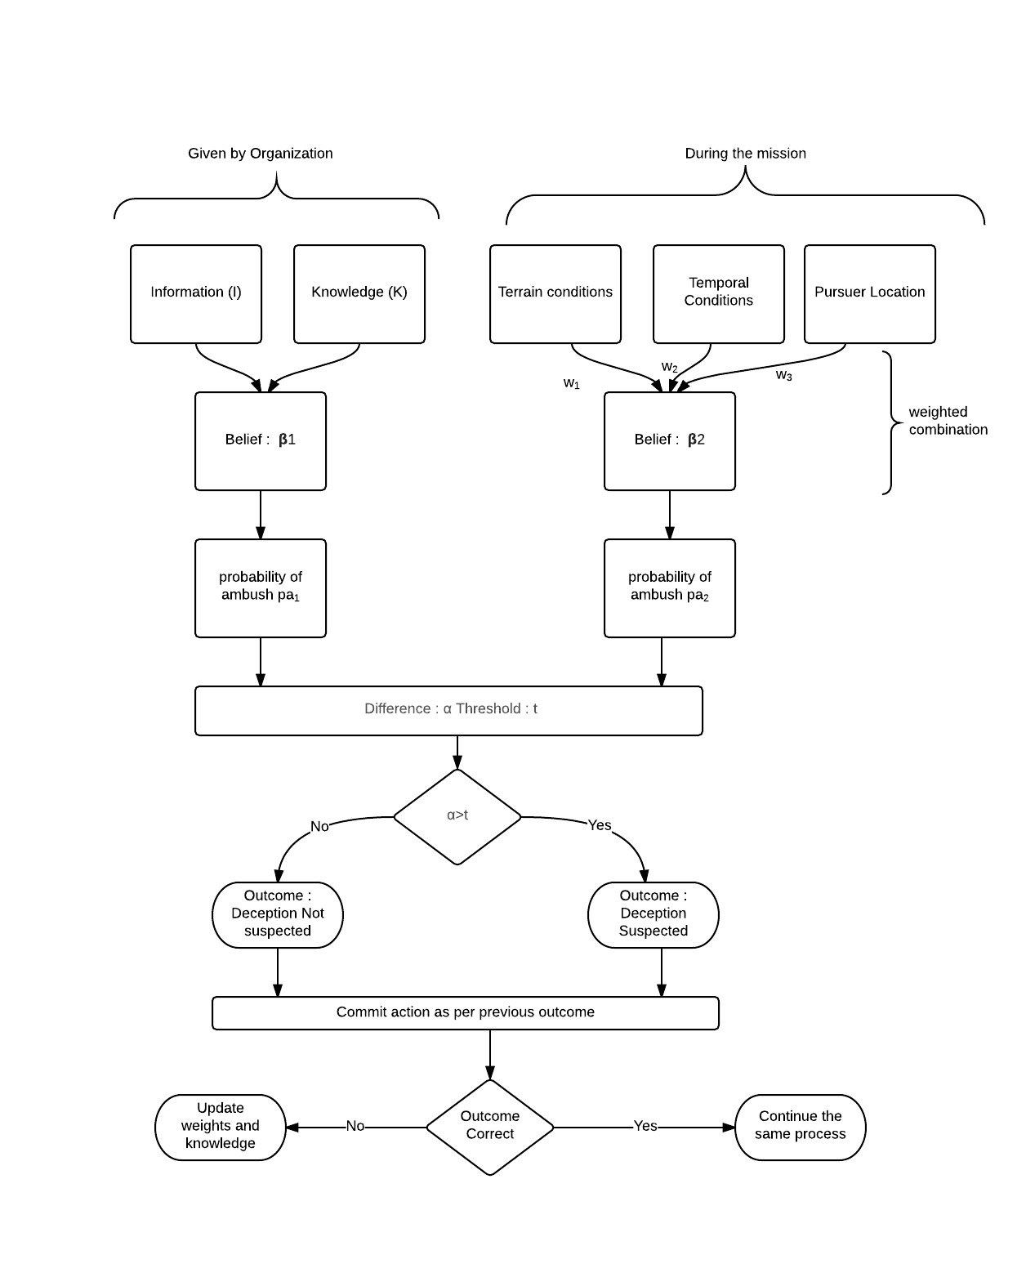

Fig 4.2 : Cognitive Deception Model

# Conclusion & Future Work

The game theoretic approach for habitat selection strategy as proposed in Chapter 2 has produced successful simulations in entirety. The approach has been able to formulate optimal pure and mixed strategies for both ambusher and evader wherein a true zero sum game matrix is available to both the parties.

Mathematical model and analysis for the deceptive scenarios in ambush avoidance and habitat selection strategies so proposed Chapter 3 has been able to establish relationship between the extent of game matrix manipulation versus the shift of the pseudo equilibrium for shifting the game’s value to deceptor’s benefit.

The model so proposed for theory of mind formulation for deception detection is though legit, it needs to validated in true / simulated conditioning for such scenario for heuristic mapping and performance evaluation. The future tasks primarily involve validation and reinforcement of this model.

# References

1. Feeley, Thomas H. and Mark A. deTurck, “Global Cue Usage in Behavioral Lie Detection,”

Communication Quarterly, 46: 109-131 (Fall 1995).

2. Buller, David B. and Burgoon, Judee K. “Interpersonal Deception Theory,” Communication Theory, 6: 203 – 242 (August 1996).

3.An Analysis of Deceptive Robot Motion Anca Dragan, Rachel Holladay, and Siddhartha Srinivasa ,The Robotics Institute, Carnegie Mellon University

4.A Cognitive Model for Exposition of Human Deception and Counterdeception ,Technical Report 1076 ,1987 , DL Lambert

5. D. G. Premack, and G. Woodruff, “Does the chimpanzee have a theory of mind?,” Behavioral and Brain Sciences, vol. 1, pp. 515-526, 1978.

6.Towards a “Theory of Mind” in Simulated Robots ,Kyung-Joong Kim , Hod Lipson , GECCO 2009

7.Game Theory of Mind Wako Yoshida*, Ray J. Dolan, Karl J. Friston, PLOS Computational Biology

8.PsychSim: Agent-based modeling of social interactions and influence,Stacy C. Marsella and David V. Pynadath